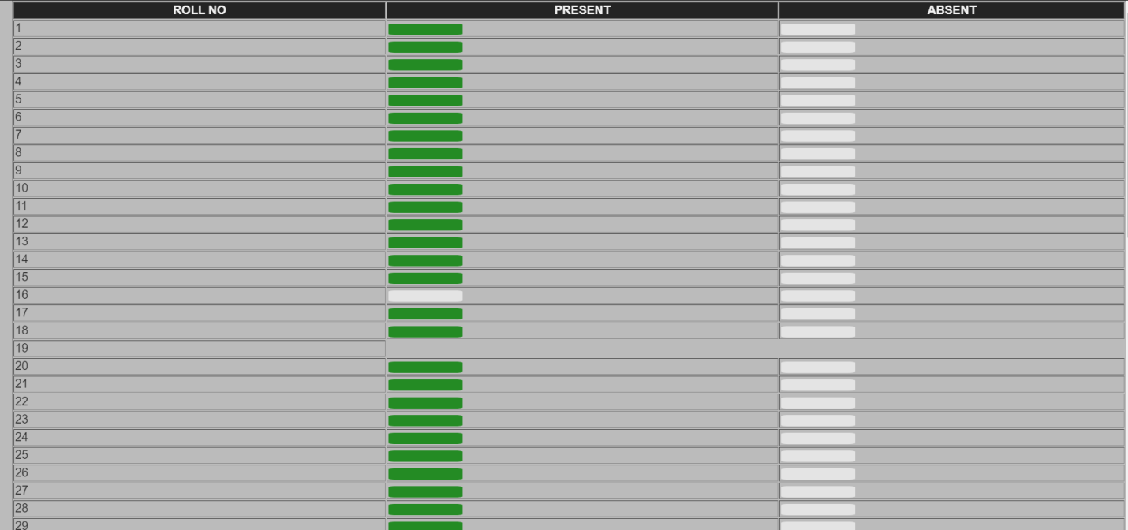

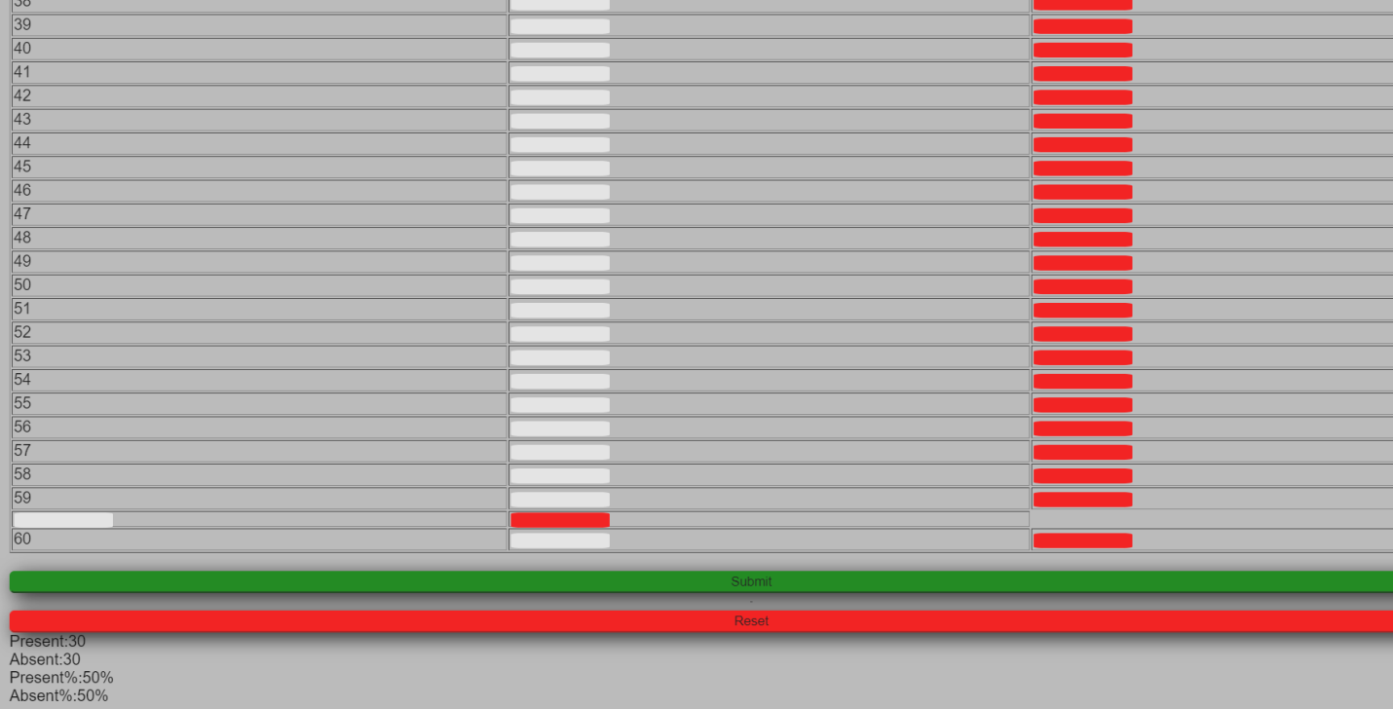

ARYAMAN MISHRA 19BCE1027

<!DOCTYPE html>

<html>

<head>

<title>Page Title</title>

<meta name="viewport" content="width=device-width, initial-scale=1">

<link rel="stylesheet" href="https://cdnjs.cloudflare.com/ajax/libs/font-awesome/4.7.0/css/font-awesome.min.css">

<script>

var counter = 0;

$(document).ready(function () {

$('#btnGetValue').click(function () {

var selValue = $('input[name=$index]:checked').val();

counter += parseInt( selValue);

$('p').html('<br/>Counter: ' + counter + '');

});

present=counter;

absent=60-counter;

pper=(present/60)\*100;

aper=100-pper;

});

</script>

<style>

body {

margin: 0;

font-family: Arial, Helvetica, sans-serif;

background-color:#bbb;

}

.topnav {

overflow: hidden;

background-color: #333;

}

.topnav a {

float: left;display: block;

color: #f2f2f2;

text-align: center;

padding: 14px 16px;

text-decoration: none;

font-size: 17px;

}

.topnav a:hover {

background-color: #ddd;

color: black;

}

.active {

color: white;

}

.topnav .icon {

display: none;

}

@media screen and (max-width: 600px) {

.topnav a:not(:first-child) {display: none;}

.topnav a.icon {

float: right;

display: block;

}

}

@media screen and (max-width: 600px) {

.topnav.responsive {position: relative;}

.topnav.responsive .icon {

position: absolute;

right: 0;

top: 0;

}

.topnav.responsive a {

float: none;display: block;

text-align: left;

}

}

/\* The container \*/

.container {

display: block;

position: relative;

padding-left: 35px;

margin-bottom: 12px;

cursor: pointer;

font-size: 220px;

-webkit-user-select: none;

-moz-user-select: none;

-ms-user-select: none;

user-select: none;

}.content {

display: block;

position: relative;

padding-left: 35px;

margin-bottom: 12px;

cursor: pointer;

font-size: 22px;

-webkit-user-select: none;

-moz-user-select: none;

-ms-user-select: none;

user-select: none;}

/\* Hide the browser's default radio button \*/

.container input {

position: absolute;

opacity: 0;

cursor: pointer;

}

.content input {

position: absolute;

opacity: 0;

cursor: pointer;

}

/\* Create a custom radio button \*/

.checkmark {

position: absolute;

top: 0;

left: 0;

height: 15px;

width: 100px;

background-color: #eee;

border-radius: 10%;

background-size:cover;

}

/\* On mouse-over, add a grey background color \*/

.container:hover input ~ .checkmark {

background-color: #ccc;

}

.content:hover input ~ .checkmark {

background-color: #ccc;

}

/\* When the radio button is checked, add a blue background \*/

.container input:checked ~ .checkmark {

background-color: green;

}.content input:checked ~ .checkmark {

background-color: red;

}

/\* Create the indicator (the dot/circle - hidden when not checked) \*/

.checkmark:after {

content: "";

position: absolute;

display: none;

}

/\* Show the indicator (dot/circle) when checked \*/

.container input:checked ~ .checkmark:after {

display: block;

}

.content:checked ~ .checkmark:after {

display: block;

}

/\* Style the indicator (dot/circle) \*/

.container .checkmark:after {

top: 9px;

left: 9px;

width: 8px;

height: 8px;

border-radius: 10%;

}

.content.checkmark:after {

top: 9px;

left: 9px;

width: 8px;

height: 8px;

border-radius: 10%;

background: white;

}

table {

width:100%;

height:auto;

border-style:outset ;

opacity:0.9;

}

div{

opacity:0.9;

}

th{

background-color:#000;

color:#ffffff;

}

#sub{

background-color:green;

box-shadow:5px 5px 19px #000;

border-color:green;

border-radius:5px;

text-transform:capitalize;

width:100%;

height:auto;

}#res{

background-color:red;

box-shadow:5px 5px 19px #000;

border-color:red;

border-radius:5px;

text-transform:capitalize;

width:100%;

height:auto;

}

</style>

</head>

<body>

</a>

</div>

<div style="padding-left:16px">

<table rowspan="20px" padding="13px" border="1px"><div>

<tr>

<th>

ROLL NO

</th>

<th>

PRESENT

</th>

<th>

ABSENT

</th>

</tr>

<tr>

<td>1</td>

<td>

<label class="container">

<input type="radio" name="1" value="1">

<span class="checkmark"></span>

</label>

</td>

<td><label class="content">

<input type="radio" name="1" value="1">

<span class="checkmark"></span>

</label></td>

</tr><tr>

<td>2</td>

<td>

<label class="container">

<input type="radio" name="2" value="1">

<span class="checkmark"></span>

</label>

</td>

<td><label class="content">

<input type="radio" name="2" value="1">

<span class="checkmark"></span>

</label></td>

</tr><tr>

<td>3</td>

<td>

<label class="container">

<input type="radio" name="3" value="1">

<span class="checkmark"></span>

</label>

</td>

<td><label class="content">

<input type="radio" name="3" value="1">

<span class="checkmark"></span>

</label></td>

</tr><tr>

<td>4</td>

<td>

<label class="container">

<input type="radio" name="4" value="1">

<span class="checkmark"></span>

</label>

</td>

<td><label class="content">

<input type="radio" name="4" value="1">

<span class="checkmark"></span>

</label></td>

</tr><tr>

<td>5</td>

<td>

<label class="container">

<input type="radio" name="5" value="1">

<span class="checkmark"></span>

</label>

</td>

<td><label class="content">

<input type="radio" name="5" value="1">

<span class="checkmark"></span>

</label></td>

</tr><tr>

<td>6</td>

<td>

<label class="container">

<input type="radio" name="6"value="1">

<span class="checkmark"></span>

</label>

</td>

<td><label class="content">

<input type="radio" name="6" value="1">

<span class="checkmark"></span>

</label></td>

</tr><tr>

<td>7</td>

<td>

<label class="container">

<input type="radio" name="7" value="1">

<span class="checkmark"></span>

</label>

</td>

<td><label class="content">

<input type="radio" name="7" value="1">

<span class="checkmark"></span>

</label></td>

</tr><tr>

<td>8</td>

<td>

<label class="container">

<input type="radio" name="8">

<span class="checkmark"></span>

</label>

</td>

<td><label class="content">

<input type="radio" name="8"value="1">

<span class="checkmark"></span>

</label></td>

</tr><tr>

<td>9</td>

<td>

<label class="container">

<input type="radio" name="9" value="1">

<span class="checkmark"></span>

</label>

</td>

<td><label class="content">

<input type="radio" name="9" value="1">

<span class="checkmark"></span>

</label></td>

</tr><tr>

<td>10</td>

<td>

<label class="container">

<input type="radio" name="10" value="1">

<span class="checkmark"></span>

</label>

</td>

<td><label class="content">

<input type="radio" name="10" value="1">

<span class="checkmark"></span>

</label></td>

</tr><tr>

<td>11</td>

<td>

<label class="container">

<input type="radio" name="11" value="1">

<span class="checkmark"></span>

</label>

</td>

<td><label class="content">

<input type="radio" name="11" value="1">

<span class="checkmark"></span>

</label></td>

</tr><tr>

<td>12</td>

<td>

<label class="container">

<input type="radio" name="12" value="1">

<span class="checkmark"></span>

</label>

</td>

<td><label class="content">

<input type="radio" name="12" value="1">

<span class="checkmark"></span>

</label></td>

</tr><tr>

<td>13</td>

<td>

<label class="container">

<input type="radio" name="13" value="1">

<span class="checkmark"></span>

</label>

</td>

<td><label class="content">

<input type="radio" name="13" value="1">

<span class="checkmark"></span>

</label></td>

</tr><tr>

<td>14</td>

<td>

<label class="container">

<input type="radio" name="14" value="1">

<span class="checkmark"></span>

</label>

</td>

<td><label class="content">

<input type="radio" name="14" value="1">

<span class="checkmark"></span>

</label></td>

</tr><tr>

<td>15</td>

<td>

<label class="container">

<input type="radio" name="15" value="1">

<span class="checkmark"></span>

</label>

</td>

<td><label class="content">

<input type="radio" name="15" value="1">

<span class="checkmark"></span>

</label></td>

</tr><tr>

<td>16</td>

<td>

<label class="container">

<input type="radio" name="16" value="1">

<span class="checkmark"></span>

</label>

</td>

<td><label class="content">

<input type="radio" name="16" value="1">

<span class="checkmark"></span>

</label></td>

</tr><tr>

<td>17</td>

<td>

<label class="container">

<input type="radio" name="17" value="1">

<span class="checkmark"></span>

</label>

</td>

<td><label class="content">

<input type="radio" name="17" value="1">

<span class="checkmark"></span>

</label></td>

</tr><tr>

<td>18</td>

<td>

<label class="container">

<input type="radio" name="18" value="1">

<span class="checkmark"></span>

</label>

</td>

<td><label class="content">

<input type="radio" name="18" value="1">

<span class="checkmark"></span>

</label></td><tr>

<td>19</td>

<tr>

<td>20</td>

<td>

<label class="container">

<input type="radio" name="19" value="1">

<span class="checkmark"></span>

</label>

</td>

<td><label class="content">

<input type="radio" name="19" value="1">

<span class="checkmark"></span>

</label></td>

</tr>

<tr>

<td>21</td>

<td>

<label class="container">

<input type="radio" name="20" value="1">

<span class="checkmark"></span>

</label>

</td>

<td><label class="content">

<input type="radio" name="20" value="1">

<span class="checkmark"></span>

</label></td>

</tr>

<tr>

<td>22</td>

<td>

<label class="container">

<input type="radio" name="21" value="1">

<span class="checkmark"></span>

</label>

</td>

<td><label class="content">

<input type="radio" name="21" value="1">

<span class="checkmark"></span>

</label></td>

</tr><tr>

<td>23</td>

<td>

<label class="container">

<input type="radio" name="22" value="1">

<span class="checkmark"></span>

</label>

</td>

<td><label class="content">

<input type="radio" name="22" value="1">

<span class="checkmark"></span>

</label></td>

</tr><tr>

<td>24</td>

<td>

<label class="container">

<input type="radio" name="23" value="1">

<span class="checkmark"></span>

</label>

</td>

<td><label class="content">

<input type="radio" name="23" value="1">

<span class="checkmark"></span>

</label></td>

</tr><tr>

<td>25</td>

<td>

<label class="container">

<input type="radio" name="24" value="1">

<span class="checkmark"></span>

</label>

</td>

<td><label class="content">

<input type="radio" name="24" value="1">

<span class="checkmark"></span>

</label></td>

</tr><tr>

<td>26</td>

<td>

<label class="container">

<input type="radio" name="25" value="1">

<span class="checkmark"></span>

</label>

</td>

<td><label class="content">

<input type="radio" name="25" value="1">

<span class="checkmark"></span>

</label></td>

</tr><tr>

<td>27</td>

<td>

<label class="container">

<input type="radio" name="26" value="1">

<span class="checkmark"></span>

</label>

</td>

<td><label class="content">

<input type="radio" name="26" value="1">

<span class="checkmark"></span>

</label></td>

</tr><tr>

<td>28</td>

<td>

<label class="container">

<input type="radio" name="28" value="1">

<span class="checkmark"></span>

</label>

</td>

<td><label class="content">

<input type="radio" name="28" value="1">

<span class="checkmark"></span>

</label></td>

</tr><tr>

<td>29</td>

<td>

<label class="container">

<input type="radio" name="29" value="1">

<span class="checkmark"></span>

</label>

</td>

<td><label class="content">

<input type="radio" name="29" value="1">

<span class="checkmark"></span>

</label></td>

</tr><tr>

<td>30</td>

<td>

<label class="container">

<input type="radio" name="30" value="1">

<span class="checkmark"></span>

</label>

</td>

<td><label class="content">

<input type="radio" name="30" value="1">

<span class="checkmark"></span>

</label></td>

</tr><tr>

<td>31</td>

<td>

<label class="container">

<input type="radio" name="31" value="1">

<span class="checkmark"></span>

</label>

</td>

<td><label class="content">

<input type="radio" name="31" value="1">

<span class="checkmark"></span>

</label></td>

</tr><tr>

<td>32</td>

<td>

<label class="container">

<input type="radio" name="32" value="1">

<span class="checkmark"></span>

</label>

</td>

<td><label class="content">

<input type="radio" name="32" value="1">

<span class="checkmark"></span>

</label></td>

</tr><tr>

<td>33</td>

<td>

<label class="container">

<input type="radio" name="33" value="1">

<span class="checkmark"></span>

</label>

</td>

<td><label class="content">

<input type="radio" name="33" value="1">

<span class="checkmark"></span>

</label></td>

</tr><tr>

<td>34</td>

<td>

<label class="container">

<input type="radio" name="34" value="1">

<span class="checkmark"></span>

</label>

</td>

<td><label class="content">

<input type="radio" name="34" value="1">

<span class="checkmark"></span>

</label></td>

</tr><tr>

<td>35</td>

<td>

<label class="container">

<input type="radio" name="35" value="1">

<span class="checkmark"></span>

</label>

</td>

<td><label class="content">

<input type="radio" name="35" value="1">

<span class="checkmark"></span>

</label></td>

</tr><tr>

<td>36</td>

<td>

<label class="container">

<input type="radio" name="36" value="1">

<span class="checkmark"></span>

</label>

</td>

<td><label class="content">

<input type="radio" name="36" value="1">

<span class="checkmark"></span>

</label></td>

</tr><tr>

<td>37</td>

<td>

<label class="container">

<input type="radio" name="37" value="1">

<span class="checkmark"></span>

</label>

</td>

<td><label class="content">

<input type="radio" name="37" value="1">

<span class="checkmark"></span>

</label></td>

</tr><tr>

<td>38</td>

<td>

<label class="container">

<input type="radio" name="38" value="1">

<span class="checkmark"></span>

</label>

</td>

<td><label class="content">

<input type="radio" name="38"value="1">

<span class="checkmark"></span>

</label></td>

</tr><tr>

<td>39</td>

<td>

<label class="container">

<input type="radio" name="39" value="1">

<span class="checkmark"></span>

</label>

</td>

<td><label class="content">

<input type="radio" name="39" value="1">

<span class="checkmark"></span>

</label></td>

</tr><tr>

<td>40</td>

<td>

<label class="container">

<input type="radio" name="40" value="1">

<span class="checkmark"></span>

</label>

</td>

<td><label class="content">

<input type="radio" name="40" value="1">

<span class="checkmark"></span>

</label></td>

</tr><tr>

<td>41</td>

<td>

<label class="container">

<input type="radio" name="41" value="1">

<span class="checkmark"></span>

</label>

</td>

<td><label class="content">

<input type="radio" name="41" value="1">

<span class="checkmark"></span>

</label></td>

</tr><tr>

<td>42</td>

<td>

<label class="container">

<input type="radio" name="42" value="1">

<span class="checkmark"></span>

</label>

</td>

<td><label class="content">

<input type="radio" name="42" value="1">

<span class="checkmark"></span>

</label></td>

</tr><tr>

<td>43</td>

<td>

<label class="container">

<input type="radio" name="43" value="1">

<span class="checkmark"></span>

</label>

</td>

<td><label class="content">

<input type="radio" name="43" value="1">

<span class="checkmark"></span>

</label></td>

</tr><tr>

<td>44</td>

<td>

<label class="container">

<input type="radio" name="44" value="1">

<span class="checkmark"></span>

</label>

</td>

<td><label class="content">

<input type="radio" name="44" value="1">

<span class="checkmark"></span>

</label></td>

</tr><tr>

<td>45</td>

<td>

<label class="container">

<input type="radio" name="45" value="1">

<span class="checkmark"></span>

</label>

</td>

<td><label class="content">

<input type="radio" name="45" value="1">

<span class="checkmark"></span>

</label></td>

</tr><tr>

<td>46</td>

<td>

<label class="container">

<input type="radio" name="46" value="1">

<span class="checkmark"></span>

</label>

</td>

<td><label class="content">

<input type="radio" name="46" value="1">

<span class="checkmark"></span>

</label></td>

</tr><tr>

<td>47</td>

<td>

<label class="container">

<input type="radio" name="47" value="1">

<span class="checkmark"></span>

</label>

</td>

<td><label class="content">

<input type="radio" name="47" value="1">

<span class="checkmark"></span>

</label></td>

</tr><tr>

<td>48</td>

<td>

<label class="container">

<input type="radio" name="48" value="1">

<span class="checkmark"></span>

</label>

</td>

<td><label class="content">

<input type="radio" name="48" value="1">

<span class="checkmark"></span>

</label></td>

</tr><tr>

<td>49</td>

<td>

<label class="container">

<input type="radio" name="49" value="1">

<span class="checkmark"></span>

</label>

</td>

<td><label class="content">

<input type="radio" name="49" value="1">

<span class="checkmark"></span>

</label></td>

</tr><tr>

<td>50</td>

<td>

<label class="container">

<input type="radio" name="50" value="1">

<span class="checkmark"></span>

</label>

</td>

<td><label class="content">

<input type="radio" name="50" value="1">

<span class="checkmark"></span>

</label></td>

</tr><tr>

<td>51</td>

<td>

<label class="container">

<input type="radio" name="51" value="1">

<span class="checkmark"></span>

</label>

</td>

<td><label class="content">

<input type="radio" name="51" value="1">

<span class="checkmark"></span>

</label></td>

</tr><tr>

<td>52</td>

<td>

<label class="container">

<input type="radio" name="52" value="1">

<span class="checkmark"></span>

</label>

</td>

<td><label class="content">

<input type="radio" name="52" value="1">

<span class="checkmark"></span>

</label></td>

</tr><tr>

<td>53</td>

<td>

<label class="container">

<input type="radio" name="53"value="1">

<span class="checkmark"></span>

</label>

</td>

<td><label class="content">

<input type="radio" name="53" value="1">

<span class="checkmark"></span>

</label></td>

</tr><tr>

<td>54</td>

<td>

<label class="container">

<input type="radio" name="54" value="1">

<span class="checkmark"></span>

</label>

</td>

<td><label class="content">

<input type="radio" name="54" value="1">

<span class="checkmark"></span>

</label></td>

</tr><tr>

<td>55</td>

<td>

<label class="container">

<input type="radio" name="55" value="1">

<span class="checkmark"></span>

</label>

</td>

<td><label class="content">

<input type="radio" name="55" value="1">

<span class="checkmark"></span>

</label></td>

</tr><tr>

<td>56</td>

<td>

<label class="container">

<input type="radio" name="56" value="1">

<span class="checkmark"></span>

</label>

</td>

<td><label class="content">

<input type="radio" name="56" value="1">

<span class="checkmark"></span>

</label></td>

</tr><tr>

<td>57</td>

<td>

<label class="container">

<input type="radio" name="57" value="1">

<span class="checkmark"></span>

</label>

</td>

<td><label class="content">

<input type="radio" name="57" value="1">

<span class="checkmark"></span>

</label></td>

</tr><tr>

<td>58</td>

<td>

<label class="container" value="1">

<input type="radio" name="58">

<span class="checkmark"></span>

</label>

</td>

<td><label class="content" value="1">

<input type="radio" name="58">

<span class="checkmark"></span>

</label></td>

</tr><tr>

<td>59</td>

<td>

<label class="container" value="1">

<input type="radio" name="59">

<span class="checkmark"></span>

</label>

</td>

<td><label class="content" value="1">

<input type="radio" name="59">

<span class="checkmark"></span>

</label></td>

</tr>

<td>

<label class="container" value="1">

<input type="radio" name="60">

<span class="checkmark"></span>

</label>

</td>

<td><label class="content" value="1">

<input type="radio" name="60">

<span class="checkmark"></span>

</label></td>

</tr>

</tr></div>

<tr>

<td>60</td>

<td>

<label class="container">

<input type="radio" name="16">

<span class="checkmark"></span>

</label>

</td>

<td><label class="content">

<input type="radio" name="16">

<span class="checkmark"></span>

</label></td>

</tr>

</table><br><center><div id ="button">

<input type="submit" value="submit" id="sub" ><hr noshade width="1px">

<input type="reset" id="res"></div></center>

</form>

Present<p></p><br>

Absent:<p></p><br>

Present%:<p></p><br>

Absent%:<p></p><br>

</body>

</html>